Memory Leak
A memory leak occurs when a program fails to release memory that it has allocated but no longer needs, leading to gradual memory exhaustion. In the context of the Linux kernel, memory leaks can cause system instability and performance degradation.
- A memory leak happens when memory is allocated (e.g., using kmalloc or vmalloc) but not freed (e.g., using kfree or vfree) when it's no longer in use.
- Over time, leaked memory accumulates, reducing the amount of available memory and potentially causing the system to slow down or crash.
Tools and Techniques for Debugging Memory Leaks:
- kmemleak
- slabtop
- ftrace
- static analysis
1. kmemleak
Kmemleak works by periodically scanning kernel memory to identify allocated blocks that are not reachable via any root objects (global variables, stack variables of running tasks, etc.). If a block is allocated but not reachable, it's considered a memory leak.
How kmemleak finds kernel memory leaks ?
- Allocation Tracking: Kmemleak keeps a close eye on all memory allocations made by the kernel. Whenever the kernel asks for memory (using functions like kmalloc, kzalloc, vmalloc), Kmemleak takes note of it. It's like Kmemleak is maintaining a sheet of all the memory the kernel has borrowed.
- Object Scanning: Next, Kmemleak starts scanning the kernel memory to find all the allocated blocks. It begins its search from known "root objects"(Memory location that kernel always know how to find it). These root objects are like starting points or well-known memory locations that the kernel uses. From these roots, Kmemleak recursively traces pointers.
- Unreachable Detection: If Kmemleak finds an allocated block during its scan, it marks it as "reachable." Any memory block that Kmemleak doesn't find during its scan is considered "unreachable." This means that there are no known pointers to that block of memory, and it's likely a memory leak.
- Reporting: Finally, Kmemleak reports any memory leaks it finds. The report includes important details like:
  - The size of the leaked memory.
  - The memory address where the leak occurred.
  - A call trace, which shows the sequence of function calls that led to the memory allocation. This is super helpful for figuring out where the leak is coming from in your code!
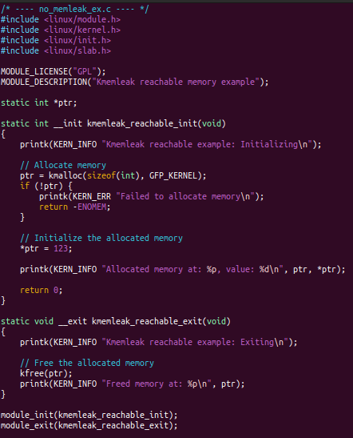
Reachable Memory (No Leak)
- This code allocates memory using kmalloc and stores the pointer in a global variable ptr.
- Because ptr is a global variable (a root object for kmemleak), the allocated memory is reachable.
- The kfree function ensures the memory is freed when the module is unloaded, preventing a leak.

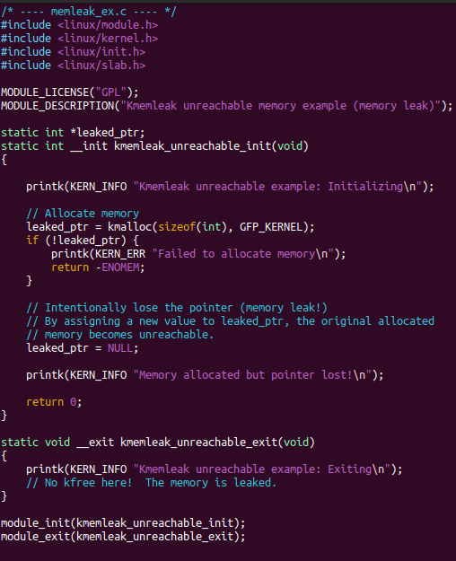
Unreachable Memory (Leak)
- This code allocates memory using kmalloc and stores the pointer in a local variable leaked_ptr. The crucial part is leaked_ptr = NULL;.
- This line overwrites the pointer to the allocated memory, making it unreachable. Kmemleak will detect this.
- There's no kfree call in the exit function, so the allocated memory is never released, resulting in a memory leak.
How to Use Kmemleak to Find and Resolve Memory Leaks
1. Enabling Kmemleak : Kmemleak is usually enabled via a kernel configuration option. Ensure that CONFIG_KMEMLEAK is enabled in your kernel configuration. You might also need to enable DEBUG_KERNEL for more detailed debugging information.
2. Boot Parameters : You can control kmemleak's behavior using kernel boot parameters. Some useful ones include:
kmemleak=on: Enables kmemleak at boot time.
kmemleak=off: Disables kmemleak at boot time.
kmemleak=scan: Forces an initial memory scan at boot time.
kmemleak=verbose: Enables verbose output.
3. Runtime Interaction :You can interact with kmemleak at runtime via the /sys/kernel/debug/kmemleak file.
Reading this file will trigger a memory scan and display any detected leaks.
Writing scan to this file will force a memory scan.
Writing clear to this file will clear the kmemleak's internal data, useful after fixing leaks to start fresh.
4. Analyzing Output: Kmemleak's output includes the address of the leaked memory, the size of the allocation, and the stack trace of where the memory was allocated. Use this information to identify the code responsible for the leak.
5. Resolving Leaks: Once you've identified the leaking code, ensure that all allocated memory is properly freed when it's no longer needed. Check for error conditions where you might be skipping the kfree call. Use code review and testing to verify that the leak is resolved.
Let’s see the kmemleak using above unreachable code.
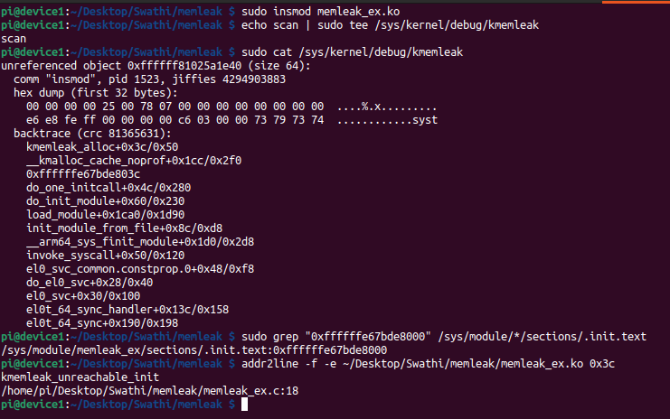
1. Load memleak_ex.ko
2. Trigger kmemleak to scan the location and find kmemleaks
3. Read the kmemleak report
4. from backtrace kmemleak reports where memory was allocated, not where it was forgotten.
Here 0xffffffe67bde803c.
5. Find instruction base address : Kernel memory for modules is always allocated in pages. On most modern systems (like your ARM64 device), a page is 4KB. Memory addresses for code sections almost always start at the beginning of a page.By "rounding down" the address to the nearest $0x1000$, you get 0xffffffd71f335000.
6. find the module by searching base address in /sys/module/*/sections/.init.text
7. After find the module using addr2line and offset find leak line and fix.
Offset = Instruction leak address – base address
**** NOTE : kmemleak reports where memory was allocated, not where it was forgotten.
Lets analyze the above kmemleak report
unreferenced object 0xffffff804ae5d200 (size 64): This indicates that kmemleak has found an unreferenced (leaked) object at the memory address 0xffffff804ae5d200. The size of the leaked object is 64 bytes.
comm "insmod", pid 2472, jiffies 4295384823: comm "insmod": The command that allocated the memory was insmod (insert module). pid 2472: The process ID of the insmod command. jiffies 4295384823: The time (in jiffies) when the memory was allocated.
hex dump (first 32 bytes): Shows the first 32 bytes of the leaked memory in hexadecimal format. This can be useful for identifying the type of data stored in the leaked memory.
backtrace (crc fb8f523a): This is the most important part for debugging. It shows the call stack at the time of the memory allocation.
- Examine the Backtrace: The backtrace is your primary tool. Look for function names that are part of your module. In your example, the backtrace includes addresses like 0xffffffed551b503c which might be within your module's code segment.
- Use addr2line: To convert the addresses in the backtrace to file names and line numbers, use the addr2line utility. You'll need the kernel image (vmlinux) and the module (.ko file) with debugging symbols. Here's how:
  - addr2line -e your_module.ko 0xffffffed551b503c
addr2line – What is it ?
addr2line is a command-line utility that's part of the GNU Binutils. It's used to convert addresses into file names and line numbers.
“addr2line translates program addresses to their corresponding source code file and line number. This is particularly useful when you have a crash dump or backtrace that gives you memory addresses, but you need to know where in the source code the issue occurred.”
You typically use addr2line with the -e option to specify the executable file and then provide the address you want to translate.

